**Practical No.5**

* Developing web application using Express Framework .

1. Hello word

* **CODE :-**

var express=require('express');

var app=express();

app.get('/',function(req,res){

res.send("Hello World");

});

app.listen(3030);

console.log("Server is waiting for client connection on port no(3030)");

* Run the Server : -

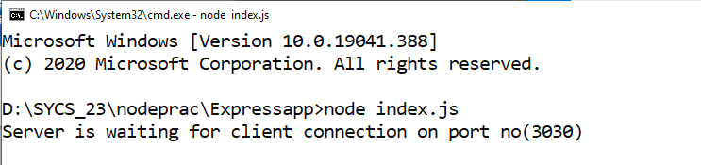

* OUTPUT :-

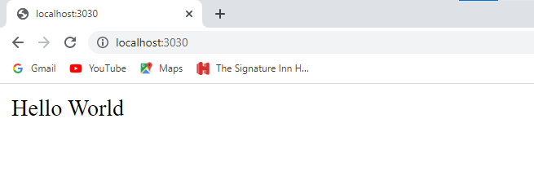

1. Using Router Facility .

* CODE (index1.js) :-

var express=require('express');

var app=express();

app.get('/home',function(req,res){

res.writeHead(200,{'Content-Type':'text/html'})

res.write("<b><i>Welcome form route home......</i></b>");

});

app.get('/login',function(req,res){

res.writeHead(200,{'Content-Type':'text/html'})

res.write("<i>Welcome form route home......</i>");

});

app.listen(3030);

console.log("Server is waiting for client connection on port no(3030)");

* Run the Server : -

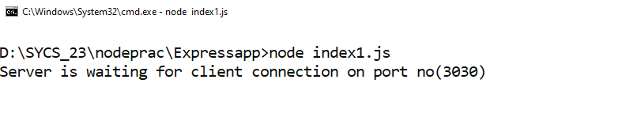

* OUTPUT :-

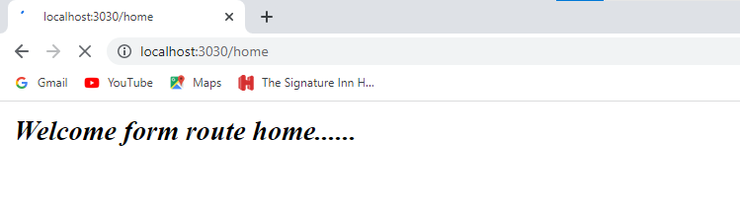

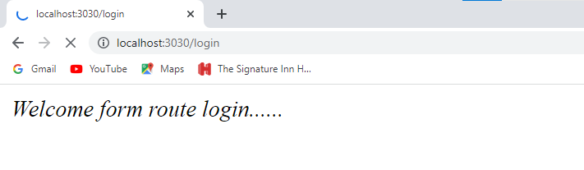

1. Passing parameter .

* CODE (index2.js) :-

var express=require('express');

var app=express();

app.get('/home/:name/:id',function(req,res){

res.writeHead(200,{'Content-Type':'text/html'})

res.write("<i><b>User name is: "+req.params.name+" and id is: "+req.params.id);

});

app.get('/login /:address',function(req,res){

res.writeHead(200,{'Content-Type':'text/html'})

res.write("<i>User address is: "+ req.params.address);

});

app.listen(3030);

console.log("Server is waiting for client connection on port no(3030)");

* Run the Server : -

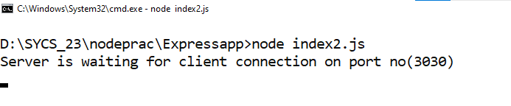

* OUTPUT :-

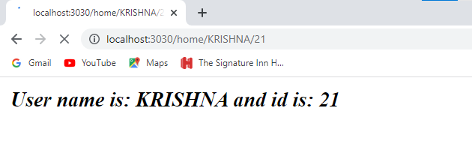

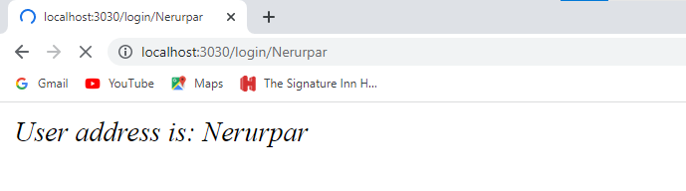

1. Specifing all router in different file .

* CODE ( routerfile.js) :-

var express=require('express');

var router=express.Router();

router.get('/home',function(req,res){

res.send("Welcome form route home......");

});

router.get('/login',function(req,res){

res.send("Welcome form route login......");

});

module.exports=router;

* CODE (runrouter.js) :-

var express=require('express');

var app=express();

var route=require('./routerfile.js');

app.use('/',route)

app.listen(3030);

console.log("Server is started");

* Run the Server : -

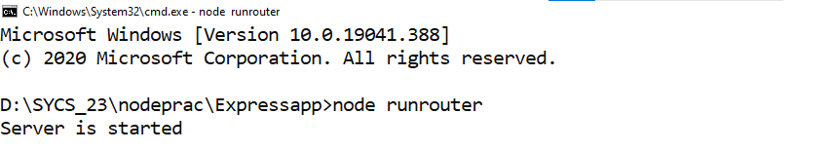

* OUTPUT :-

